UDC (enter index)
ARTICLE TITLE

Academic degree, full name, ORCID of authors
Country, city, name of institution
E-mail:

Space for a short abstract. It should be concise, up to 100 words, and demonstrate what has been done in the work. The abstract should use all the keywords provided, which are selected so that the probability of finding the article through search engines is as high as possible.
Keywords: 5 to 10 words or short phrases that convey the content of the research in addition to the title of the article.

The introductory part (untitled) familiarizes the reader with the field of research and its existing problems, highlighting why it is important. It is necessary here to provide an overview of the relevant literature, indicating the problems requiring additional research that are addressed in the work. The introduction concludes with a clearly stated objective for the study. This is followed by the main part, which should be clearly structured into sections and, if necessary, subsections. The titles of these should be formatted as shown below.

Requirements for Article Content
A mandatory condition for an article to be accepted for consideration is its compliance with generally accepted standards for scientific publications, i.e., it must contain:
— a description of the problem, alongside an analysis of publications from the last five years, and a justification of the need for the research;
— a clearly formulated objective of the study;
— a main section that includes a discussion and interpretation of the results;
— conclusions.
In addition, the editorial board is interested in the following aspects:
— the possibility of practical application of the research results;
— the relevance of the tables and illustrations, and the absence of any duplication of the information they contain;
— the adequacy of the use of literary sources;
— the accuracy of terminology;
— the composition of the manuscript, including the justification of its length.

Manuscript Formatting

General Guidelines
While the editorial board does not impose strict requirements on manuscript formatting, it does recommend adhering to the guidelines below to make further work on the manuscript easier.
The text should be typed in this template file using a 12 pt Times New Roman font with 1.5 line spacing and no hyphenation.
The main part may contain sections such as 'Study Samples', 'Research Methods', 'Research Results' and 'Discussion', and must end with a 'Conclusions' section.

Using the Equation Editor
Equation editors, such as MathType or the one built into your word processor, should only be used to type complex equations, special symbols in superscripts, subscript expressions, etc. (for example: ). Equations should be aligned to the left without indents, with their respective numbers in parentheses to the right, as shown below:
; (1)
. (2)
Do not use the equation editor when the standard text editor menu offers sufficient options, for example, for typing simple formulas such as
J₀(y) = J₁ exp(–y), (3)
or Greek letters (α, β, γ, δ, ε ...), font highlights (A, B, c), sub- or superscript indices (J₀, K^{–1}, H_{min}), etc.

Figures
Figures should appear in the text after they are first mentioned (E.g., ... in Fig. 1 ...).
Ideally, illustrations should not exceed 40% of the article's total volume.
The research results presented in the figures should be interpreted in the text. The interpretation should not simply duplicate the information given in the figure caption or be limited to describing the dependencies shown. Instead of uninformative phrases like 'Fig. 1 shows the graph of the dependence of A on B. The figure shows that as B increases, the value of A monotonically decreases', provide further explanation, such as this: 'As can be seen from Fig. 1, as B increases, the value of A decreases monotonically, indicating that...'
Examples of different types of figures and captions are given below.

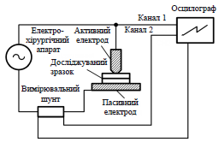
Fig. 1. Simplified structure of an electrosurgical device

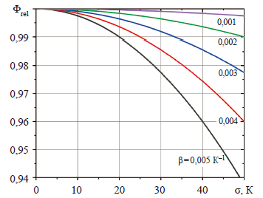
Fig. 2. Dependence of relative luminous flux on standard temperature deviation for LEDs for different values of temperature coefficient β

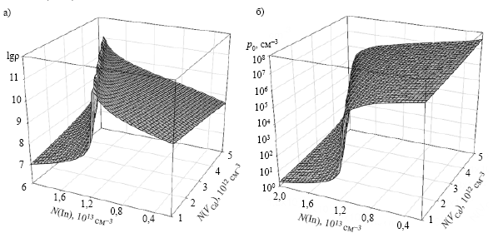
Fig. 3. Dependence of the logarithm of specific resistance (a) and concentration of free holes p₀ (b) on the concentrations of indium and cadmium vacancies in the range 2∙10¹² ≤ N(In) ≤ 2∙10¹³ cm^{–3}; 1∙10¹² ≤ N(V_{Cd}) ≤ 5∙10¹²

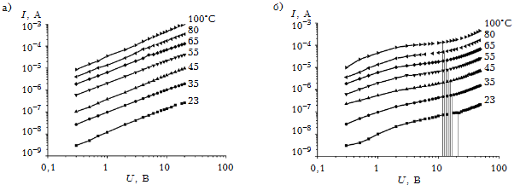

Fig. 4. VAC of a three-barrier photodiode structure obtained at different temperatures and external voltage polarities:

а — (+)m₁ – р – n – m₂(–); b — (–)m₁ – р – n – m₂(+)

When preparing illustrations, bear in mind that the printed version of the journal is in black and white. If one illustration shows graphs of dependencies for different conditions, the curves should differ from each other in more ways than just colour. For example:

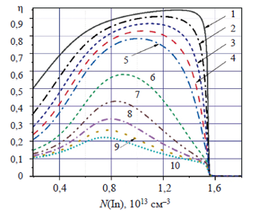

Tables
Tables should be typed in 10 pt Times New Roman fon and placed right after their first mention in the text (E.g., '... in Table 1 ...').

Table 1

Initial conditions of the simulated system
Number  of cells | Converter  power,  W | Cell capacity,  mA·h | Cell SoC, %
Number  of cells | Converter  power,  W | Cell capacity,  mA·h | 1 | 2 | 3 | 4 | 5 | 6
6 | 4 | 3000 | 40 | 50 | 60 | 70 | 80 | 90

Table 2

Parameters of graphene/n-Si structures obtained with different durations of graphene layer deposition
Parameter | Time for applying graphene layers, min
Parameter | 5 | 10 | 15
Rectification factor R_{F} (at |V| = 2 V) | 1,2 | 1,9 | 2,2
Built-in potential ϕ_{k}, V | 1,35 | 1,32 | 1,27
Sequential resistance R_{S}, Ω | 3,4⋅10⁶ | 3,4⋅10³ | 3,7⋅10³

If there is only one table, do not give it a number and reference it in the text like this: '... as shown in the table...'.

Parameters for stand calibration
f, МГц | R, Ом | X, Ом | φ, °
0,44 | 75 | 0,95–1,39 | 0,72–1,07
1,76 | 75 | 3,78–5,58 | 2,89–4,26
3,5 | 75 | 7,52–11,10 | 5,72–8,42

Do not duplicate the same results in tables and figures. When choosing the form of data presentation, focus on the ultimate goal: if specific numerical data is important, then a tabular form will be more useful; if it is important to clearly show patterns, then it is better to do so in graphic form.

List of References
At least half of the total number of sources should be works published within the last five years. Keep the total number of your own publications cited in the paper below 25–30% of the total number.
Arrange the list of references in the order in which you cite them in the text, where they are given as numbers in square brackets. When citing several sources at once, indicate each reference number separately in square brackets, separating them with commas, or use a dash to indicate a range, for example: [1], [3], [5] or [1]–[4]. If the text contains numerical values, formulas, and other factual data borrowed from books, indicate not only the book itself, but also the page in the book where this information can be found (for example, [2, p. 418]).
It is not recommended to include references to normative documents in the list of references, and if this cannot be avoided, it is better to mention them directly in the text of the article.
The reference list is formatted according to IEEE rules (see examples below).

Conclusions
The conclusions section should not describe what the researchers did in the study (this belongs in the abstract), but rather show that they achieved the stated goal, present the results of the work and recommendations for their practical application, and identify the main directions for further research. Phrases such as “The study showed that ...”, “The authors found that ...”, “The developed methodology allows ...” and so on will help you formulate your conclusions correctly.
Make sure that the title, aim of the study, and conclusions are consistent with each other.
__________

DESCRIPTION OF REFERENCES

Reference Formatting Templates According to IEEE Guidelines
Book | [1] A. Author, Title of the Book, xth ed. City of Publisher, Country: Publisher, Year.
Book Chapter | [2] B. Author, “Title of chapter,” in Title of Book, xth ed., C. Editor, Ed. City of Publisher, Country: Publisher, Year, pp. xxx–xxx.
Journal Article | [3] D. Author and E. Author, “Title of article,” Title of Journal, vol. xx, no. yy, pp. zz–zz, Month, Year. doi: 10.xxx/xxxxxxxxxx
Conference Paper | [4] F. Author, “Title of paper,” in Proceedings of the Conference Name, City, Country, Year,  pp. xxx–xxx. doi: 10.xxx/xxxxxxxxxx
Technical Report | [5] G. Author, “Title of report,” Company/Institution, City, Country, Report no. xxx, Year.
Website | [6] H. Author, “Title of webpage,” Website Name. [Online]. Available: URL. [Accessed: Month Day, Year].
Thesis/Dissertation | [7] I. Author, “Title of thesis,” M.S. thesis, Department, University, City, Country, Year.
Standard | [8] Standard Name/Number, “Title of Standard,” Publishing Organization, Year.

Example of a Reference List
[1] A. S. Sedra and K. C. Smith, Microelectronic Circuits, 7th ed. New York, NY, USA: Oxford Univ. Press, 2015.
[2] S. M. Sze, “Physics and properties of semiconductors,” in Physics of Semiconductor Devices, 3rd ed.,
K. K. Ng, Ed. Hoboken, NJ, USA: Wiley, 2007, pp. 5–75.
[3] V. Sergiichuk, O. Oliinyk and A. Boikynia, “State of the art and outlook for development of Hall effect sensors for electronic devices,” Technology and Design in Electronic Equipment, no. 3–4, pp. 3–14, 2024. doi: 10.15222/TKEA2024.3-4.03
[4] A. Manzhelii, D. Lipko and O. Bondarenko, “Comparative Analysis of DC-DC Converters for Micro-Mobility Vehicles,” 2024 IEEE 7th International Conference on Smart Technologies in Power Engineering and Electronics (STEE), Kyiv, Ukraine, 2024, pp. TT1.45.1-TT1.45.5, doi: 10.1109/STEE63556.2024.10748120.
[5] National Semiconductor Laboratory, “Report on advanced CMOS fabrication techniques,” Tech. Rep. NSL-2020-05, Berkeley, CA, USA, 2020.
[6] IEEE, “IEEE Xplore Digital Library,” [Online]. Available: https://ieeexplore.ieee.org. [Accessed: Feb. 6, 2026].
[7] P. Davis, “Power management in embedded systems,” Ph.D. dissertation, Dept. Elect. Eng., Stanford Univ., Stanford, CA, USA, 2019.
[8] IEEE Standard 802.11, “Wireless LAN Medium Access Control (MAC) and Physical Layer (PHY) Specifications,” IEEE, 2016.

